**Project brief:**

I developed a MATLAB function for the calculation of the price of an average strike Asian call option that is priced according to the Heston model (Heston, 1993) with Monte Carlo simulation using the Euler discretization (Lord, Koekkoek and Van Dijk, 2007) scheme.

I also studied on the impact of changing different parameters on the option pricing valuation.

**Background Knowledge:**

An average strike Asian call option has the payoff



at the expiration date *T.* It is assumed that the price of the underlying *St* , *0* ≤ *t* ≤ *T*, follows a stochastic process under the risk-neutral measure with stochastic volatility σ*t* of the following form:



This model is often referred to as Heston (1993) model. The stochastic variance follows a mean-reverting process. The meaning of the parameters is the following:

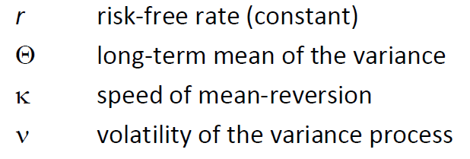

*Wt* is a two-dimensional Wiener process that is *N*(0,Σ) – distributed with covariance matrix:



An instrument with the path dependent payoff in (1) can be valued using Monte Carlo methods. The time horizon can be split into *N* intervals. Generating *M* paths for the asset price, one can approximate the continuous payoff function taking the arithmetic average of the *N*+1 asset prices. The option price V0 can then be approximated as follows:



**An Example from Monte Carlo Simulations:**

For parameter set:



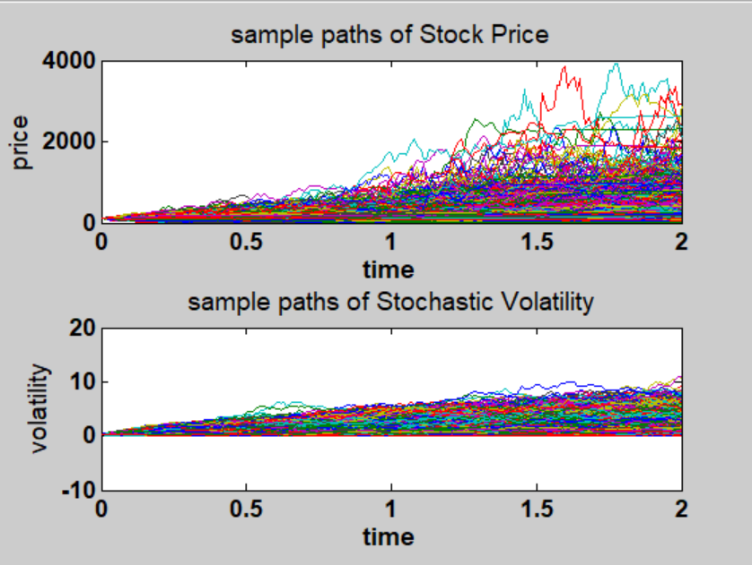

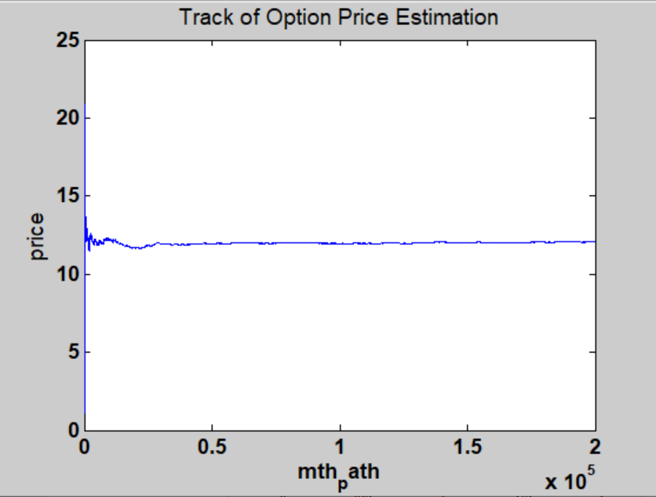

The simulation result is that the fair price for this option is 12.05.

From the second image we can observe that the simulation result converges after around 100k paths generated by Monte Carlo simulations. By calculating the sample standard deviation, we can conclude that to achieve a 95% confidence that the error is smaller than 5%, 65k paths are good enough.

**The Impact of Initial Volatility:**

Higher volatility leads to higher option price: Vega (${ⅆf}/{dσ}$) > 0.

|  |  |
| --- | --- |
| $σ_{0}$ = 0.1 | $\overline{V0}$**= 9.70** |
| $σ_{0}$ = 0.4 | $\overline{V0}$**= 14.10** |
| $σ_{0}$ = 0.7 | $\overline{V0}$**= 17.99** |

The reason is that a larger $σ_{0}$ gives a **fatter** right tail to the stock price.

